**Problem Statement 1 -** Create a Data Frame using dictionary containing students’ marks details with columns Student_ID, Student_Name, Gender, Sub1, Sub2, Sub3 with the marks of 20 students.

Or you can create an excel file for the same and import it.

1. Find the mean and median marks in each subject.
2. Find the mode of ‘Gender’ column.
3. Find the variance and standard deviation of marks in each subject

**CODE -** import pandas as pd import numpy as np

data = {

"Student_ID": range(1, 21),

"Student_Name": [f"Student_{i}" for i in range(1, 21)],

"Gender": np.random.choice(["Male", "Female"], size=20),

"Sub1": np.random.randint(50, 100, size=20),

"Sub2": np.random.randint(50, 100, size=20),

"Sub3": np.random.randint(50, 100, size=20),

}

df = pd.DataFrame(data)

mean_marks = df[["Sub1", "Sub2", "Sub3"]].mean() median_marks = df[["Sub1", "Sub2", "Sub3"]].median()

mode_gender = df["Gender"].mode()[0]

variance_marks = df[["Sub1", "Sub2", "Sub3"]].var() std_dev_marks = df[["Sub1", "Sub2", "Sub3"]].std()

print("Mean Marks:\n", mean_marks) print("\nMedian Marks:\n", median_marks) print("\nMode of Gender column:", mode_gender) print("\nVariance of Marks:\n", variance_marks) print("\nStandard Deviation of Marks:\n", std_dev_marks) print("Program created by Nisha Belwal..")

# OUTPUT –

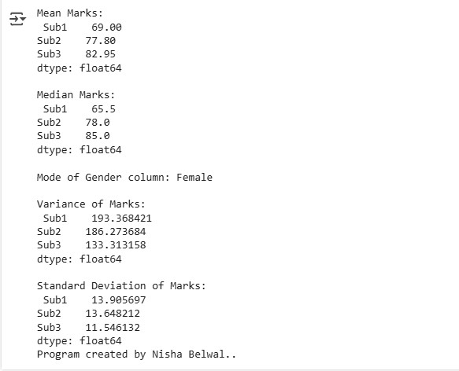

**Problem Statement 2 -** Define two matrices. Find their sum, difference, transpose and product of two matrices.

**CODE –** import numpy as np

1. = np.array([[1, 2, 3], [4, 5, 6], [7, 8, 9]])
2. = np.array([[9, 8, 7], [6, 5, 4], [3, 2, 1]])

sum_matrix = A + B

diff_matrix = A - B

transpose_A = A.T

transpose_B = B.T

product_matrix = np.dot(A, B) # Matrix multiplication

print("Matrix A:\n", A) print("\nMatrix B:\n", B) print("\nSum of Matrices:\n", sum_matrix) print("\nDifference of Matrices:\n", diff_matrix) print("\nTranspose of Matrix A:\n", transpose_A) print("\nTranspose of Matrix B:\n", transpose_B) print("\nProduct of Matrices:\n", product_matrix) print("Program created by Nisha Belwal..") **OUTPUT –**

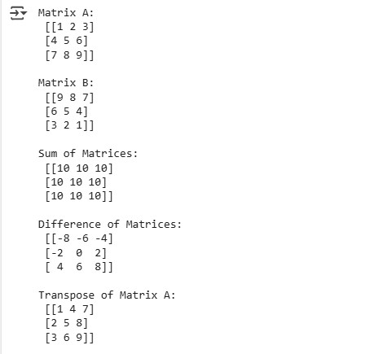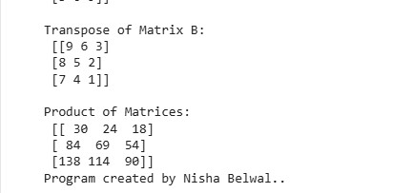

**Problem Statement 3 -** Write a Python Program to perform following operations.

1. Read file with the help of function
2. Rename file
3. Delete file

# CODE –

import os

def read_file(filename): try: with open(filename, 'r') as file: content = file.read() print("File Content:\n", content) except FileNotFoundError:

print("Error: File not found!")

filename = "sample.txt"

read_file(filename)

new_filename = "renamed_sample.txt" try:

os.rename(filename, new_filename) print(f"File renamed to {new_filename}") except FileNotFoundError:

print("Error: File not found for renaming!")

try:

os.remove(new_filename) print(f"File {new_filename} deleted successfully") except FileNotFoundError:

print("Error: File not found for deletion!")

print("Program created by Nisha Belwal..")

# OUTPUT –

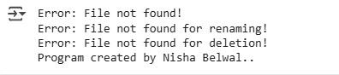

**Problem Statement 4 -** Write a Python program to count the number of lines in a text file using enumerate.

# CODE –

def count_lines(filename): try: with open(filename, 'r') as file: line_count = sum(1 for _, _ in enumerate(file, start=1)) print(f"Total number of lines in '{filename}':", line_count) except FileNotFoundError:

print("Error: File not found!")

filename = "sample.txt"

count_lines(filename)

print("Program created by Nisha Belwal..")

# OUTPUT –

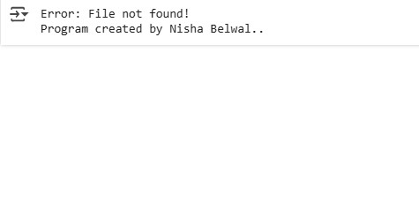

**Problem Statement 5 -** Write a Python program to create a module named as calculator.py. which defines four functions addition, subtraction, multiplication and division, and import this module to another module to use its functions.

# CODE 1 –

# calculator.py - A simple calculator module

def addition(a, b):

return a + b

def subtraction(a, b):

return a - b

def multiplication(a, b):

return a * b

def division(a, b): if b != 0:

return a / b else:

return "Error! Division by zero."

# CODE 2 –

# main.py - Importing and using the calculator module

import calculator

num1 = 10

num2 = 5

# Using functions from calculator.py

print("Addition:", calculator.addition(num1, num2)) print("Subtraction:", calculator.subtraction(num1, num2)) print("Multiplication:", calculator.multiplication(num1, num2)) print("Division:", calculator.division(num1, num2))

# OUTPUT –

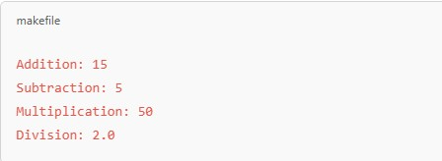

**Problem Statement 6 -** Construct clusters by using KMeans algorithm on a sample data set. Take the value of k=3, visualize all three clusters using scatter plot also print the Silhouette score of the clustering.

# CODE –

import numpy as np import matplotlib.pyplot as plt from sklearn.cluster import KMeans from sklearn.metrics import silhouette_score from sklearn.datasets import make_blobs

X, _ = make_blobs(n_samples=300, centers=3, cluster_std=1.0, random_state=42)

kmeans = KMeans(n_clusters=3, random_state=42, n_init=10) clusters = kmeans.fit_predict(X)

sil_score = silhouette_score(X, clusters)

print(f"Silhouette Score: {sil_score:.3f}")

plt.figure(figsize=(8, 6))

plt.scatter(X[:, 0], X[:, 1], c=clusters, cmap='viridis', marker='o', edgecolors='k') plt.scatter(kmeans.cluster_centers_[:, 0], kmeans.cluster_centers_[:, 1], c='red', marker='X', s=200, label='Centroids') plt.title("K-Means Clustering (k=3)") plt.xlabel("Feature 1") plt.ylabel("Feature 2") plt.legend() plt.show()

print("Program created by Nisha Belwal..")

# OUTPUT –

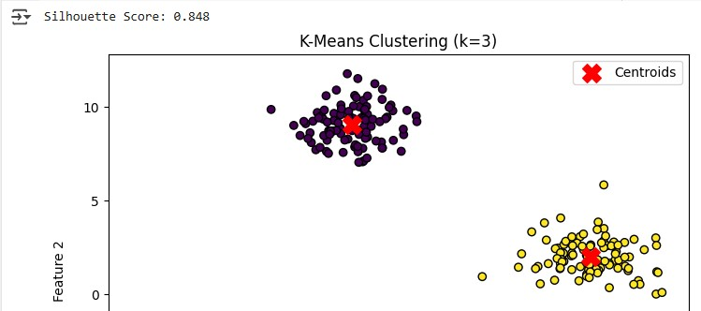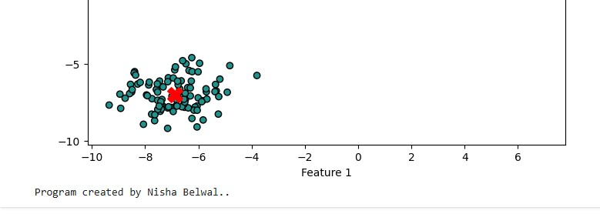

**Problem Statement 7 -** WAP to check if a value entered by a user is palindrome or not.

# CODE –

def is_palindrome(value):

value = str(value)

return value == value[::-1]

user_input = input("Enter a value to check if it's a palindrome: ")

if is_palindrome(user_input): print(f"'{user_input}' is a palindrome!") else: print(f"'{user_input}' is not a palindrome.")

print("Program created by Nisha Belwal..")

# OUTPUT –

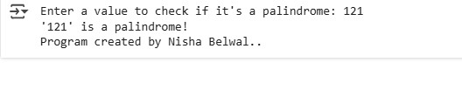

**Problem Statement 8 -** WAP to print a factorial of a number.

# CODE –

def factorial(n): if n < 0:

return "Factorial is not defined for negative numbers!" elif n == 0 or n == 1:

return 1 else:

fact = 1 for i in range(2, n + 1):

fact *= i

return fact

num = int(input("Enter a number to find its factorial: "))

print(f"Factorial of {num} is: {factorial(num)}")

print("Program created by Nisha Belwal..")

# OUTPUT –

